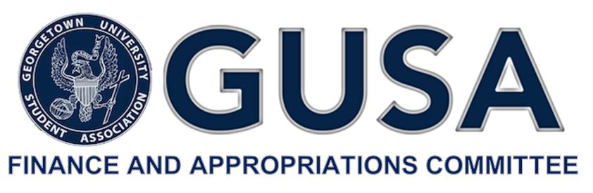

Dear Applicant,

Thank you for your interest in applying for funding from the Student Activities Fee for FY20. The Committee is excited to spend time getting to know the unique ways that your organization, program, or project contributes to the vitality of student life at Georgetown.

The following application is designed to give the Committee a better picture as to the impact your organization, program, or project makes on student life. The application is organized into three parts, A through C, explained in detail below. The Committee will hold two informational sessions to provide a comprehensive overview of the process and will hold office hours during the duration of the application period. Please refer to the email announcement of this application for specific dates and locations.

While the Committee will consider each Part B application it receives, it maintains the right to deny a Part B application from entrance into Budget Summit and full consideration for funding. As you complete your application, please keep in mind that the Committee will likely receive far more requests than the Student Activities Fee can accommodate. This fact necessitates the Committee make near-impossible judgements regarding the positive impact that each dollar allocated can make to enhance student life.

The Committee thanks you for the time and effort spent compiling your financial data and answering our questions. We look forward to working with you throughout this process.

Best Regards,

Hayley Grande

Chair, GUSA Finance and Appropriations Committee

GUSA Finance & Appropriations Committee

**FY20 Budget Summit**

Student Activity Fee Funding Application

(APPLICATION B- For Non-Advisory Boards)

Please email this application and accompanying materials to gusafinapp@georgetown.edu by **Sunday, February 10, 2019 at 11:59 pm.**

**PART A.**

Name of Organization:

Mission of Organization:

GMS Worktags:

Total Amount of Funding Requested:

**PART B.**

Please complete the Financial Information (B) FY20 excel document and attach it to your email submission.

**PART C.**

Please answer the following questions in detail and provide any relevant documents:

1. Describe the program/project you would like to fund, implement or enhance.
2. How are decisions made about the direction of this program? How are students  
   involved in the decision making process?
3. In what ways does this program/project enhance student life at Georgetown  
   University? How many students will it affect?
4. What funding sources currently support this program? Will these sources continue to provide funding at the same level this year? What other sources have been explored before coming to GUSA?
5. Will this program comply with all University policies?
6. What level of financial risk does this project entail?
7. In what way will this program/project expand or relieve a financial burden on  
   students participating in this program?
8. What is the long-term financial impact of this project? Will there be ongoing  
   maintenance costs?
9. Will this program need more money in future years? To the best of your ability  
   provide information on project costs for the next two years.
10. Has your organization/group previously applied to the Budget Summit? How much was the organization allocated? How was it used?

**CERTIFICATION:**

By signing below, I hereby certify that the information enclosed is accurate to the best of  
my knowledge.

**Funding Request Form Submitted By:**

**Name of Group Student Chair:**

**Signature (type your name):**

**Name of Group Advisor:**

**Signature (type your name):**

**Date:**

**Contact Email:**

**Contact Phone Number:**